IMPLEMENTATION OF BACKTRACKING ALGORITHM

Objectives

The objectives of this lab are:
- To understand the basic concept of the backtracking algorithm.
- To implement the backtracking algorithm using Python.
- To learn how recursion is used in solving AI search problems.
- To identify invalid choices and return to previous steps when needed.
- To understand the use of backtracking in constraint-based problems.
Theory:
Backtracking is an important algorithmic technique used to solve problems by trying different possible solutions one at a time. It is mainly used when a problem has multiple choices and the correct solution must satisfy certain rules or constraints. The main idea of backtracking is to build a solution gradually. At each step, the algorithm selects one possible option and checks whether it is valid. If the selected option is valid, the algorithm moves forward and continues building the solution. However, if the selected option does not satisfy the required condition, the algorithm goes back to the previous step and tries another option. This process of returning to the previous step is called backtracking.
Backtracking is generally done with recursion. The function literally calls itself to get to the next stage. Then, when it hits a dead-end and needs to retreat, it goes back to the last call it made. Because of this, backtracking is awesome for issues where you have to look through every combo but can rule out duds early on. This method rocks in AI search problems and constraint satisfaction puzzles. It's used in things like solving logic puzzles, the N-Queens challenge, Sudoku, graph coloring, map coloring, and finding paths in mazes. For these, the program needs to follow rules while making a series of choices.

Where backtracking shines is in how it narrows down searches efficiently. Rather than waste time checking each full option, it first verifies if part of a solution works. If it finds a piece that doesn’t fit, it just stops looking down that road. So, it does a way more organized search compared to just guessing, making tough problems easier to crack.
Source Code: https://github.com/dilasha68/AI-LABS/tree/main/LAB%202
Output:
- Adversial – search
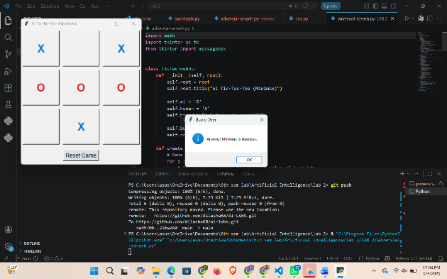
- Backtracking
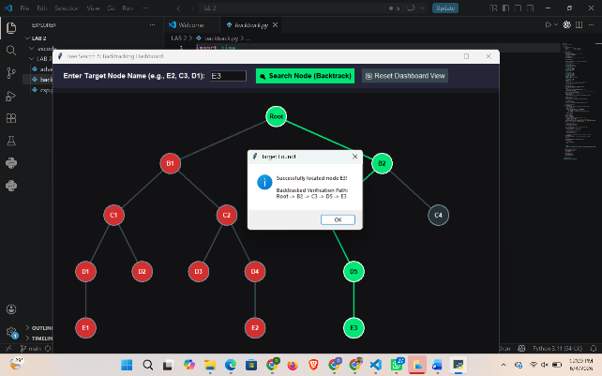
- csp
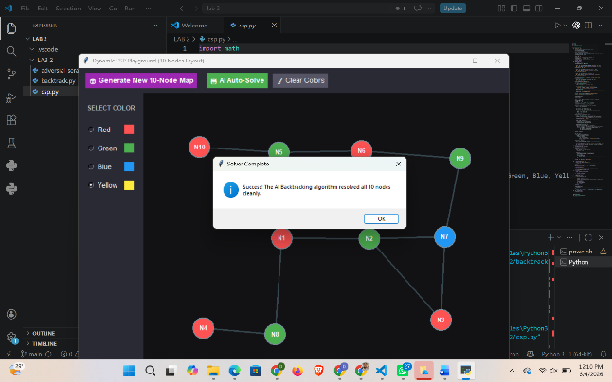

Discussion
In this lab, backtracking algorithm was implemented using Python. The program would check each possibility recursively, backing off when it hit an invalid choice, and then try a different option. This really showed how backtracking works – it methodically searches through possible solutions by rejecting wrong turns and going back to explore other options.
Conclusion
Thus, in this experiment we saw firsthand how the algorithm weeds out bad paths and doubles back to find what does work. Also, we learned that backtracking is super helpful for dealing with search and constraint-based issues in AI.

